Overview

[neerajpoladen@gmail.com](mailto:neerajpoladen@gmail.com) +91-7093551955

Phases of pipeline:

1. Get the video features(width,height,fps)
2. Initate the mediapipe for landmarks
3. 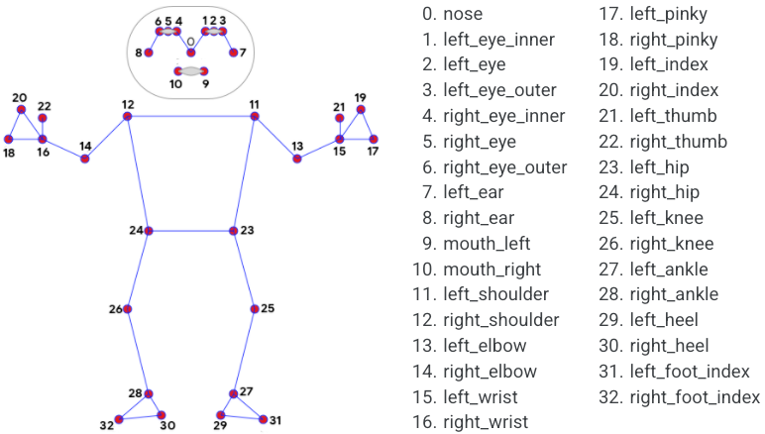as we can see from the above figure, calculate the landmarks for hips,knees,ankles,shoulder by

landmark[mp_pose.PoseLandmark.Part.value].x for(x coordinate)

1. As we got the coordinates now we can find the angle by some trigonometry, say to find the angle of knee bent we can find the angle between 23,25,27{order is important here}
2. Represent all the lines and circles in the frames of video using the coordinates
3. Increment the counter by 1 when a successful rep completes
4. As soon as angle is 180 degrees start the rest timer
5. If moved start the bent timer
6. Reduce the duplicate frames by simple hashtable
7. Finally, create a video for output using videoWriter

Instructions

1. Upload the video into the folder containing the program
2. Set the path in program[cv2.VideoCapture(PATH)]
3. Set the desired output path in cv2.VideoWriter(DESTINATION PATH)]
4. Run the program
5. Programs exits when the duration of video ended and output would be is destination path

----Thank you----